 | RATE AND EXTENT OF REACTION
 | INTRODUCTION
• | Firstly, before one could embark on trying to understand the rate of reaction; needs to look back into the topic. This topic has two words i.e. rate and Reaction. Hence, it is essential to start by explaining the meaning of each word/term.
 | RATE
• | Rate is the amount of time taken for a change to occur i.e. how fast/slow did the change occur. In our interest the change refers to the reaction. Also the change may be measured by mass, volume, concentration.
• | Mathematically, the rate is denoted as follows:
 | $Rate= \frac{∆m}{∆t} or Rate= \frac{∆c}{∆t} or Rate= \frac{∆v}{∆t}$
 | Chemical Reaction
• | A chemical reaction is the conversion of reactant(s) to product(s).
 | TYPES OF REACTIONS
• | In grade 9, Natural Sciences a chemical reaction is defined as the combination of two or more substances to form a new substance. In the hypothetical equation below A combines with B to form C. And this type of a reaction is a synthesis reaction.
 | A + B → C
• | However, there are other types of reaction: i.e. decomposition reaction where one substance breaks apart to form two or more substances  C → A + B
 | REACTION RATE
• | A reaction rate is the change in concentration of reactants or products per unit time.
• | This definition is also shown mathematically
 | $$Rate=\frac{∆[products]}{∆t}$$
 | Or
 | $$Rate= \frac{∆[reactants]}{∆t}$$
Note:
Questions may also include calculations of rate in terms of change in mass/volume/ number of moles per time.
Units of rate of reaction can be g∙s ⁻¹ / dm ³ ∙s ⁻¹ / mol∙s⁻¹.

Reaction rate defined graphically

 |  | Measuring change in the concentration of reactants |  |  | Measuring change in the concentration of Products
Concentration (mol.dm⁻³) |  |  |  | Concentration (mol.dm⁻³)
 |  | Time(s) |  |  | Time (s)
• | Reactants get reduced as they form products during the progress of the
 | reaction, whilst products increase. And if one of the reactants gets used
 | up then the reaction stops, i.e. no more products will be formed. Then that
 | reactant is called a limiting reagent because it limits the reaction progress
• | Also, the shape of the graph is informative i.e. when the slope of the graph is steep then the rate of reaction is fast.
 | Note: Graphs can also be in terms of change in mass/volume/ number of moles per time.

 |  |  | Collision theory
 | • |  | Collision theory states that for any reaction to take place reactants must collide. Due to those collisions there are two possibilities i.e. ineffective collision and effective collision.
 | • |  | An ineffective collision is whereby reactants collided but could not yield products.
 | • |  | This is shown by the following hypothetical equation:  A + B → A + B
 | • |  | Whereas, an effective collision is whereby reactants collided to form products (new substance)
 | • |  | This is shown by the following hypothetical equation:  A + B → C + D
 | • |  | In collision theory, in order for reactants to collide effectively and rate be measured they must meet the following requirements.
 |  |  | 1. Have sufficient kinetic energy to overcome repulsion of their electron
 |  |  | clouds and nuclei.
 |  |  | 2. Be correctly orientated so that the reactive sides of one approach the
 |  |  | reactive side of the other
 |  |  | Factors Affecting the Rate of Reaction
 |  |  | Chemical reactions are used in many industries to produce bulk materials that are essential for daily lives. Therefore, for industries to sustain production, they need to have faster chemical reactions to produce more products at minimal time. The following factors have an effect on the rate of chemical reaction
1. Concentration (for solutions only)
2. Pressure (for gases only)
3. Surface area (for solids)
4. Temperature
5. Catalyst
6. Nature of reacting substance
1. |  | Concentration
• |  | Concentration is defined as the number of particles per unit volume.
• |  | Concentration only applies where there is at least one reactant that is a solution.
• |  | If the concentration of reactants is increased; the number of particles per unit volume increases, resulting in the increase of the number of particles with the correct orientation. The number of effective collisions per unit time increases. Hence, the rate of reaction will increase.
• |  | Also, if the concentration of reactants is decreased; the number of particles per unit volume decreases, resulting in reduction of particles with the correct orientation. The number of effective collisions per unit time decreases. Hence, the rate of reaction will decrease.
2. |  | Pressure
• |  | In physics pressure is defined as the force per unit area.
• |  | Pressure is applicable to gases only.
• |  | If the pressure in a system is increased; the distance between the particles decreases, resulting in the increase of the number of particles with the correct orientation. The number of effective collisions increases, hence the rate of reaction increases.
• |  | Also, if the pressure in a system is decreased; the distance between the particles increases, resulting in the decrease of the number of particles with the correct orientation. The number of effective collisions decreases, hence the rate of reaction decreases.
3. |  | Temperature
• |  | Temperature is the measure of the average kinetic energy of molecules.
• |  | When temperature is increased, the average kinetic energy of molecules increases, resulting in more effective collisions, hence the rate of reaction increases.
4 |  | Positive Catalyst
• |  | A positive catalyst is a chemical substance that increases the rate of chemical reaction without itself undergoing permanent change.
• |  | Adding a positive catalyst in a reaction reduces the activation energy, resulting in more particles making effective collisions, hence the rate of reaction increases.
 |  | The Maxwell-Boltzmann Distribution Curves
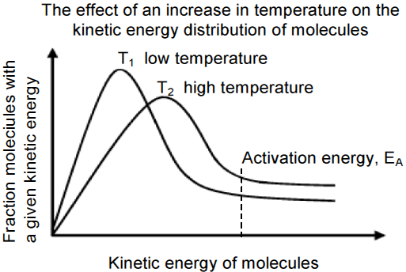

 |  | When temperature is low, there are more molecules with smaller values of kinetic energy (T1 is above), and when temperature is high, there are more molecules with higher values of kinetic energy (T2 is above).

Increase in concentration of a reactant
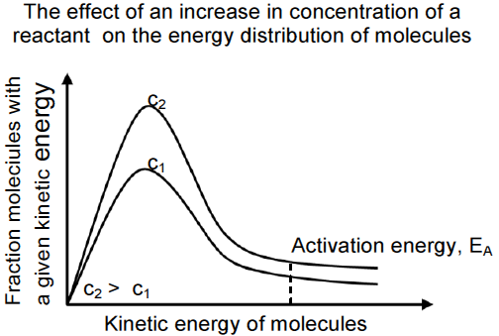
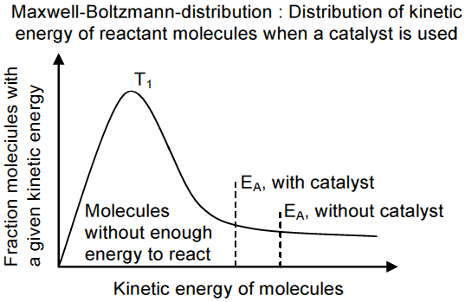
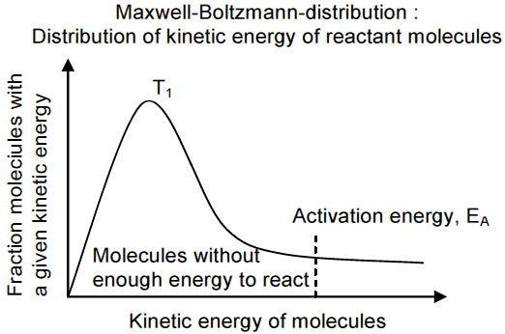
If a catalyst is added, the activation energy is decreased, hence the number of molecules that make effective collisions increases. Therefore the reaction rate increases.
5 | Surface area
• | Surface area refers to the total number of reactive sites exposed for the reaction to occur.
• | The reactive site exposed is in line with correct orientation of reactants for enhancing effective collision
• | This applies when one of the reactants is a solid
• | Solid can come in the form of Chunk, granules and powder
• | In all these forms of solids, the molecules expose to react are only the visible part
• | So, when the solid state changes from block/chunk to granules and eventually to powder.
• | The surface area increases, then number of reactive sites available for collisions per unit time increases.
• | Hence, the rate of reaction increases.
6. Nature of reactants
- Reaction rate is determined by bond energy, hence the lower the bond energy the higher the rate of reaction
- E,g magnesium reacts with hydrochloric acid faster than copper

ENERGY and CHEMICAL CHANGE
• | In a chemical reaction energy is used to break old bonds, and energy is released when new bonds form.
• | Therefore during a reaction energy of the system changes; and that change in energy is called enthalpy change (heat of reaction)
• | Enthalpy change is calculated using the following equation:
 | $${∆H=H}_{products}- H_{reactant}$$
• | Also in a reaction products are not formed directly, however an intermediate molecule forms. This intermediate molecule is neither a reactant nor a product and is called Activated Complex
• | However, activated complex eventually breaks up to form products
• | An activated complex is defined as the molecule which is highly unstable, high energy and it breaks up to form products.
• | The potential energy of this activated complex is equal to the activation energy of the reaction.
• | There are two types of reactions as far as energy is concerned i.e.  1. Exothermic reaction  2. Endothermic reaction.
 | Exothermic Reaction
• | Exothermic reaction is the reaction that releases energy
 | Properties of an Exothermic Reaction
 | 1. Reactants absorb less energy than the energy that is produced
 | 2. Energy of reactants is greater that the energy of products
 | 3. the enthalpy change(heat of the reaction) of the reaction is negative
 | 4. also known as spontaneous reaction
 | Example :Mg_{(s)} + 2HCl _{(aq)} → MgCl_{2(aq)} + H_{2(g)} : ∆H = -ve
 | Graph : Shows energy profile of an exothermic reaction
 | Potential energy (kJ.mol⁻¹) |  | Ea  R  ∆H Energy realesed  P
 | Reaction progress/ time (s)
 | Endothermic Reaction
• | chemical reaction that require (absorbs) energy
 | Properties of an Endothermic Reaction
 | 1. Reaction that absorbs more energy it produces
 | 2. Energy of reactants is less that the energy of products
 | 3. the enthalpy change (heat of the reaction) of the reaction is positive
 | 4. non-spontaneous reaction
 | Graph : Shows the energy profile for endothermic reaction
 | Potential energy (kJ.mol⁻¹) | Energy realesed  Ea P  ∆H  R
 |  | Reaction progress/time (s)

=+

